(Approx. 919 words)

Build a ‘Green’ PC on a Budget
By Rob Limbaugh, President, Danbury Area Computer Society, CT
www.dacs.org
Relimbaugh (at) dacs.org

This article has been obtained from APCUG with the author’s permission for publication by APCUG member groups; all other uses require the permission of the author (see e-mail address above).

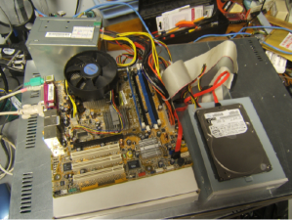 intro.jpg

We’re constantly bombarded by the subject of energy conservation—‘green’ this and ‘green’ that. I think that much of our problem is our ‘disposable society’. On top of that it seems that most people tend to be ‘green’ only if it fits into their budget and lifestyle. It is a little difficult to rationalize spending $25,000 on a solar array for a house that will take a decade to ‘pay for itself’.

But, if you happen to be looking for another computer and you’re willing to spend some spare time and effort, you can rescue good parts from a premature demise and save money at the same time. How? Read on!

Timing Is Everything
Around here we have ‘transfer stations’ to which local residents take their refuse and recyclables if they don’t have curbside pickup or another service. The transfer station is somewhat of a presorting point before everything goes to a larger dump site.

What amazes me is that people seem to be willing to pay a few bucks to throw away things that could be recycled or disposed of for no cost—just a bit more effort. No matter. That works out well for me—I can shop!

I need more computer equipment like I need another hole in my head. What I always seem to lack are good motherboards to match up with the spare DVD drive here and spare hard drive there. On a recent trip to the dump I hit pay dirt! Someone had dropped off a bunch of computer equipment and I got there early enough in the day to have relatively fresh dibs!

Weeding Out Junk
Knowing that ‘garbage’ tends to be at dumps, I look for specific traits when considering a rescue of any would-be junk. Last thing I want to do is throw it away when I get home and you can’t exactly test things at a transfer station. This is a good exercise in knowing your hardware as you can just take home the good stuff and leave everything else there. As luck would have it, I found a gutted case with a motherboard stripped of everything but the CPU and heat sink. Even the BIOS battery was gone! They did leave the power supply, though.

Back to the Bench
So far my out-of-pocket expense is $0.00 and I’d like to keep it that way! I take the guts home and blow them out with an air-compressor. The minimum needed to successfully power on a motherboard are a power supply, motherboard, CPU, fan, and memory. Unfortunately I didn’t have any memory on hand for this motherboard, so now it’s time to do some leg work and see if I should consider spending the money when I don’t even know if the board works.

The motherboard, in this case, can be identified by a silkscreen of “PTGD1-LA” between the PCI slots. This cross-references to a board used in HP Pavilion Ax00 systems. This gives me access to motherboard details so I know what the connecting pins are, memory requirements, and other details necessary to do troubleshooting. Yippee, memory for this board is on sale right now—1GB for $27!

Good, Bad, or Ugly?
In this situation I presume the components are good until proven faulty. Having all the dust blown off, I sniff around the motherboard. That’s right… using my nose, I sniff around the motherboard. The power supply, too. Fried components have a burnt smell. All smells good.

Powering on a working system with the memory removed should get yield ‘memory error’ beep codes from the motherboard. I power everything on and get beep codes indicating bad memory. During this time I listen for fan noise out of the power supply and the CPU fan. Nothing that sounds like skateboard wheels on pavement. Things are looking good!

Many motherboards take CR2023 batteries for memory, including this one. I picked up a two-pack along with a 1GB stick of PC-3200 memory. So far I’m out about $30 and still don’t know if this will fire up completely—but odds are in my favor. Besides, if I needed PC-3200 and PC batteries today, I’d need them in the future for another find later.

Hot Dog!
With the memory seated and a battery added, I fired up the machine and the screen came up! Woo-Hoo! Looking really good now! And it’s a P4!

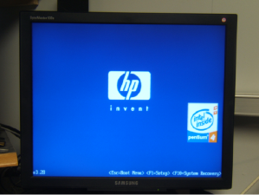 poweron.jpg

I gathered up a spare SATA hard drive and DVD drive and connected them to the system. BIOS reported the devices. Turns out this is an Intel P4 3.0GHz CPU with Hyper-threading.

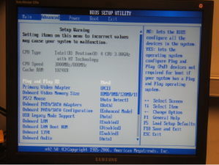poweron.jpg

Wrapping It Up
Sure this isn’t a screaming-fast brand new machine, but it has much potential and is still quite useful. Someday, the parts will wind up being recycled through the transfer station for good—but not today. For now, it has a new life. This board has integrated video, audio, and four SATA ports. It has IDE, USB, PCI Express, and legacy connections. It is also very quiet. This is not bad find at all! I will probably use this as the start of my network storage system.

Now if only I could get my hands on some DVD-RW drives that don’t work...

